|  |
| --- |
| **Document highlight:**   * Tool Installation   + Visual Studio Code     - Live Server (add-on)   + HTML5Up * In VS Code, load the upzipped template folder files and go to index.html file * Code in HTML (using the index file) * Promote the files (ie., in GitHub) * Sampling live page (public) |

|  |
| --- |
| 1. Tool Installation |

**Download and install (follow instruction guide):**

**Visual Studio Code** (VS Code)<https://visualstudio.microsoft.com/downloads/>  
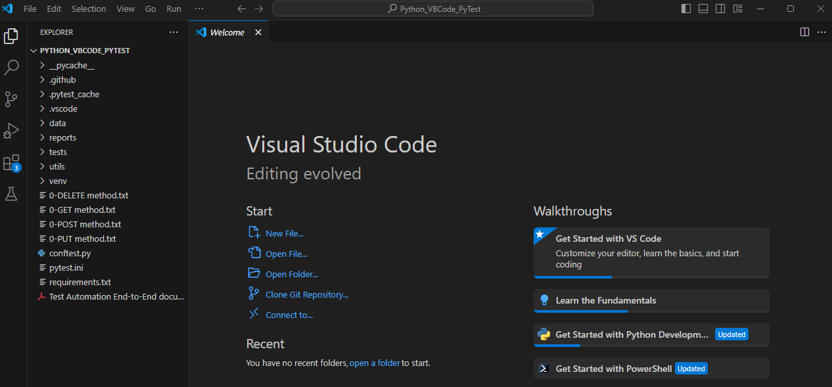

In VS Code, download and install the Live Server add-on  
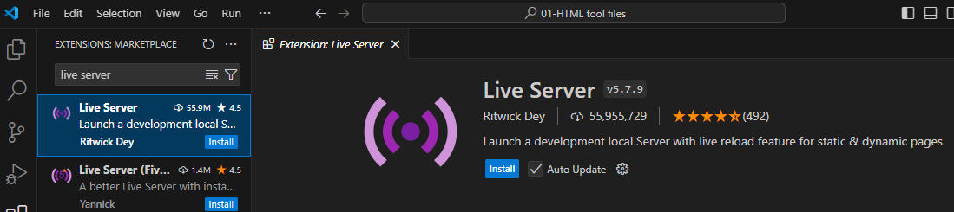

**HTML5Up** (pick and download a free template)<https://html5up.net/>  
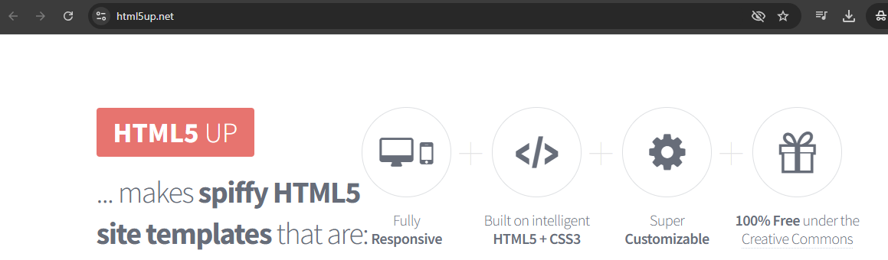

|  |
| --- |
| 1. In VS Code, load the upzipped template folder files and go to index.html file |

**Go to the index file**  
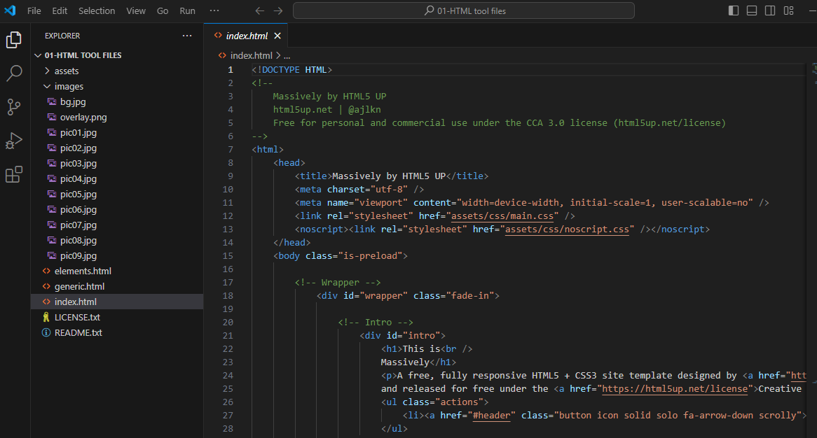

**Open with Live Server**  
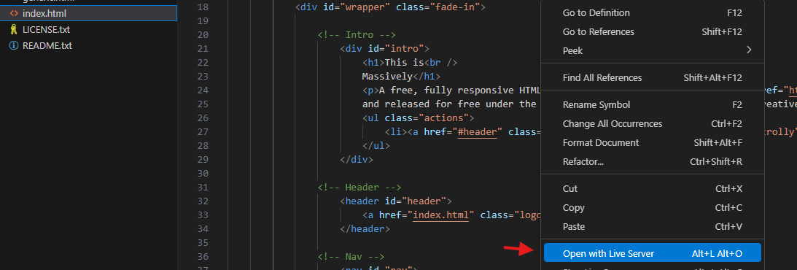

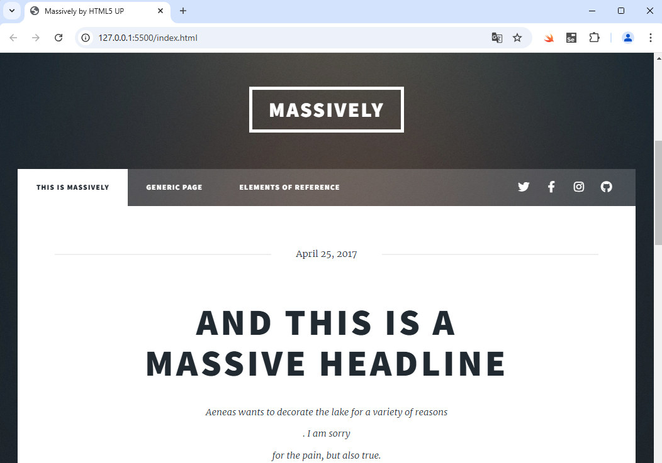

|  |
| --- |
| 1. As a snippet, code in HTML (using the index file) |

|  |
| --- |
| 1. Promote the files (ie., in GitHub) |

|  |
| --- |
| 1. Live page (public) |

**\*\*\*\*\*\*\*\*\*\*\*\*\*\*\*\*\*\*\*\*\*\*\*\*\*\*\*\*\*\*\*\*\*\*\*\*\*\*\*\*\*END\*\*\*\*\*\*\*\*\*\*\*\*\*\*\*\*\*\*\*\*\*\*\*\*\*\*\*\*\*\*\*\*\*\*\*\*\*\*\*\***